Chapter 29-1

singly linked lists

- We will start with a simple model of a linked list, namely, a singly linked list.

front

- While there is a first node, second node, and so on, these nodes are dynamically allocated form the heap and thus are not consecutive in memory.
- A LinkedList grows dynamically to meet the needs of an application.

The Node<T> class

- A class Node object is used to represent a node in a linked list.

//Example 29-1-1
//Node.java
public class Node<T>
{
public T value;
public Node<T> next;
public Node()
{
value = null;
next = null;
}
public Node(T item)
{
value = item;
next = null;
}
}

Build a singly linked list

//Example 29-1-2
public class Demo
{
public static void main(String[] args)
{
Node<String> front, n1, n2, n3; //line 7
n1=new Node<String>("Peter"); //line 8
n2=new Node<String>("Paul"); //line 9
n3=new Node<String>("Mary"); //line 10
n1.next= n2; //line 11
n2.next= n3; //line 12
front= n1; //line 13
System.out.println(n1.value); //line 14
System.out.println(n2.value); //line 15
System.out.println(n3.value); //line 16
System.out.println(front.value); //line 17
System.out.println(front.next.value); //line 18
System.out.println(front.next.next.value); //line 19
}
}

Process a singly linked list

//Example 29-1-3
public class Demo
{
public static void main(String[] args)
{
Node<String> front= new Node<String>("Peter"); //line 7
front.next=new Node<String>("Paul"); //line 8
front.next.next=new Node<String>("Mary"); //line 9
Node<String> p=front; //line 10
while (p!=null) //line 11
{
System.out.println(p.value); //line 13
p=p.next; //line 14
}
}
}

toString and seqSearch

//Example 29-1-4
public class SinglyLinkedList<T>
{
// Pre: front points to the first node in a linked list, whose last node must have a null reference
//Return:"null" if front is null; all the values in the list in the form "[value1, value2, …]" otherwise
public static <T> String toString(Node<T> front)
{
if (front==null) return "null";

Node<T> frontCopy = front;

String result = "[" + front.value;
while (frontCopy.next != null)
{
frontCopy = frontCopy.next;
result += ", " + frontCopy.value;
}
result += "]";

return result;
}

// Pre: front points to the first node in a linked list, whose last node must have a null reference
// Return: null if key not in list; a reference to the node in list that matches key otherwise
public static <T> Node<T> seqSearch (Node<T> front, T key)
{
Node<T> node = front;
while (node != null)
{
if (node.value.equals(key))
return node;

node = node.next;
}

return null;

}
}

//Example 29-1-5
import java.util.Scanner;
public class Demo
{
public static void main(String[] args)
{
Scanner f=new Scanner(System.in);
Node<String> front= new Node<String>("Peter");
front.next=new Node<String>("Paul");
front.next.next=new Node<String>("Mary");
System.out.println(SinglyLinkedList.toString(front)); //line 10
System.out.print("Enter key:");
String s=f.nextLine();
Node<String> result= SinglyLinkedList.seqSearch(front, s); //line 13
if (result==null) System.out.println(s+" not in list");
else System.out.println(result.value+" in list");
}
}
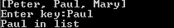

Building a linked list dynamically

//Example 29-1-6
import java.util.Scanner;
public class SinglyLinkedList<T>
{
…
//Pre: A sequence of integers entered via keyboard; -1 is sentinel
//Return: A linked list of the input integers in reverse
public static Node<Integer> buildReverseList()
{
Scanner f=new Scanner(System.in);
Node<Integer> front=null, node=null; //line 7
while (true)
{
int num=f.nextInt(); //line 11
if (num==-1) break; //line 12
node = new Node<>(num);
node.next = front;
front = node;
}
return front;
}
}

//Example 29-1-7
public class Demo
{
public static void main(String[] args)
{
Node<Integer> front= SinglyLinkedList.buildReverseList();
System.out.println(SinglyLinkedList.toString(front));
}
}
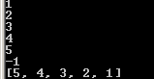

//Example 29-1-8
public class SinglyLinkedList<T>
{
…
//Pre: A sequence of integers entered via keyboard; -1 is sentinel
//Return: A linked list of the integers
public static Node<Integer> buildList()
{
Scanner f=new Scanner(System.in);
Node<Integer> front = null, node = null, temp= null;
boolean first = true;
while (true)
{
int num=f.nextInt();
if (num==-1) break;
node = new Node<Integer>(num);

if (first)
{
front = node;
first = false;
}
else
{
temp = front;
while (temp.next != null)
temp = temp.next;

temp.next = node;
}
}
return front;
}

private static <T> void link(Node<T> )
{

}
}

//Example 29-1-9
public class Demo
{
public static void main(String[] args)
{
Node<Integer> front= SinglyLinkedList.buildList();
System.out.println(SinglyLinkedList.toString(front));
}
}
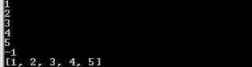

insertAfter

//Example 29-1-10
public class SinglyLinkedList<T>
{
…
//Pre: p cannot be null
//Post: item inserted after the node referenced by p
//Return:The new node inserted
public static <T> Node<T> insertAfter(Node<T> p, T item)
{
Node<T> newNode=new Node<T>(item);
newNode.next = p.next;
p.next = newNode;
return newNode;
}
}

//Example 29-1-11
import java.util.Scanner;
public class Demo
{
public static void main(String[] args)
{
Scanner f=new Scanner(System.in);
Node<Integer> front= SinglyLinkedList.buildList();
System.out.print("Insert what?");
int item=f.nextInt();
System.out.print("After what?");
int after =f.nextInt();
Node<Integer> result= SinglyLinkedList.seqSearch(front, after);
if (result==null) System.out.println(after+" not in list. Insert failed.");
else
{
SinglyLinkedList.insertAfter(result, item);
System.out.println(item+" inserted after "+after);
}
System.out.println(SinglyLinkedList.toString(front));
}
}
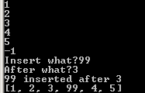

Delete operations

//Example 29-1-12
public class Demo
{
public static void main(String[] args)
{
Node<Integer> front=SinglyLinkedList.buildList(); //line 7
System.out.println(SinglyLinkedList.toString(front));

front = front.next; //line 10, delete first node, list has at least 1 node
System.out.println(SinglyLinkedList.toString(front));

Node<Integer> temp = front;
while (front.next.next != null)
temp = temp.next;

temp.next = null;
//line 13, delete last node, list has at least 2 nodes
//line 14
//line 15
//line 16
System.out.println(SinglyLinkedList.toString(front));

temp = front;
temp.next = temp.next.next;
//line 19, delete the second node
//line 20
System.out.println(SinglyLinkedList.toString(front));
}
}
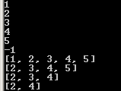

Remove a particular element

//Example 29-1-13
public class SinglyLinkedList<T>
{
…
//Post: item removed from list if exists.
//Return: Since the first element can be the element removed, front might change. Thus the
// method returns front. The caller must assign the return value to the list pointer.
public static <T> Node<T> remove(Node<T> front, T item)
{
Node<T> curr = front, prev = null;

while (curr != null)
{
if (curr.value.equals(item))
{
if (prev == null) front = front.next;
else prev.next = curr.next;
break;
}
else
{
prev = curr;
curr = curr.next;
}
}

return front;
}
}

//Example 29-1-14
import java.util.Scanner;
public class Demo
{
public static void main(String[] args)
{
Scanner f=new Scanner(System.in);
Node<Integer> front=SinglyLinkedList.buildList();
System.out.println(SinglyLinkedList.toString(front));
System.out.print("Delete what?");
int item=f.nextInt();
front=SinglyLinkedList.remove(front, item);
System.out.println(SinglyLinkedList.toString(front));
}
}
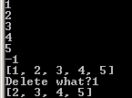

getMaxNode

//Example 29-1-15
public class SinglyLinkedList<T>
{
…
//Desc: Find the mode with max value
//Pre: front cannot be null
//Return: The node with max value
public static <T extends Comparable<? super T>> Node<T> getMaxNode(Node<T> front)
{
Node<T> maxNode = front, curr = front.next;

while (curr != null)
{
if (maxNode.value.compareTo(curr.value) < 0)
maxNode = curr;

curr = curr.next;
}

return maxNode;
}
}

//Example 29-1-16
public class Demo
{
//Desc: Read a list of integers and output them in descending order.
public static void main(String[] args)
{
Node<Integer> front=SinglyLinkedList.buildList();
Node<Integer> p=null;
System.out.print("Ordered list: ");
while (front != null)
{
maxNode = SinglyLinkedList.getMaxNode(front);
System.out.print(maxNode.value + " ");
front = SinglyLinkedList.remove(front, maxNode.value);
}
System.out.println();
}
}
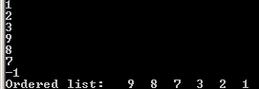

Programming Exercise

Part I

Among all the SinglyLinkedList methods we discussed in class, all except buildList and buildReverseList are parameterized. Modify class SinglyLinkedList to exclude these 2 non-parameterized methods. Instead, write parameterized methods insertFirst, insertLast, removeFirst, removeLast for the SinglyLinkedList class.

Hint:
- Complete the following class SinglyLinkedList<T>:
public class SinglyLinkedList<T>
{
public static <T> String toString(Node<T> front)
{
//given
}
public static <T> Node<T> seqSearch (Node<T> front, T key)
{
//given
}
public static <T> Node<T> insertAfter(Node<T> p, T item)
{
//given
}
public static <T> Node<T> remove(Node<T> front, T item)
{
//given
}
public static <T extends Comparable<? super T>> Node<T> getMaxNode(Node<T> front)
{
//given
}
//Pre: front cannot be null
//Post: First element removed from list.
//Return:The updated front reference
public static <T> Node<T> removeFirst(Node<T> front)
{
//you will write
}
//Pre: front cannot be null
//Post: Last element removed from list.
//Return:Since the first element can be the element removed, front might change. Thus the
// method returns front
public static <T> Node<T> removeLast(Node<T> front)
{
//you will write
}
//Post: item inserted as first element of list.
//Return:The updated front reference
public static <T> Node<T> insertFirst(Node<T> front, T item)
{
//you will write
}
//Post: item inserted as last element of list.
//Return:Since item can be inserted as the first element, front might change. Thus the
// method returns front
public static <T> Node<T> insertLast(Node<T> front, T item)
{
//you will write
}
}

Hand in/email:
- SinglyLinkedList.java.

Part II

Write a main program to support the following program:
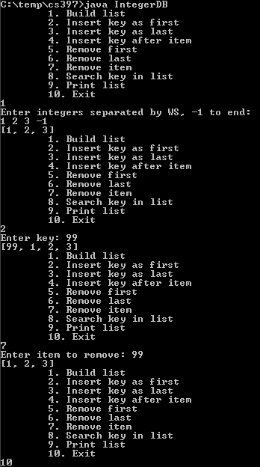

Note:
- You must print the list after each menu operation has completed to show the updated list.
- This is not a database application in that the program does not save the list on exit.

Hint:
- Menu item 1 calls buildList (not a SinglyLinkedList method; write this in class IntegerDB.java):
//Pre: A sequence of integers entered via keyboard; -1 is sentinel
//Return:A linked list of the integers
public static Node<Integer> buildList()
{
//read integers and call SinglyLinkedList.insertLast and return the list
}
- Menu item 2 calls insertFirst
- Menu item 3 calls insertLast
- Menu item 4 calls insertAfter
- Menu item 5 calls removeFirst
- Menu item 6 calls removeLast
- Menu item 7 calls remove
- Menu item 8 calls seqSearch
- Menu item 9 calls toString
Hand in/email:
- IntegerDB.java.

